Building a Sales & Geo Analytics Warehouse for Contoso in Microsoft Fabric
Overview
Contoso—a global retail brand—wants to modernize its data landscape to strengthen sales and location-based insights. Today, sales and customer information lives in separate systems, which makes it hard for business analysts and citizen developers to get a complete picture. To fix this, Contoso will bring everything together on Microsoft Fabric, enabling unified queries, robust sales analytics, and geography-driven reporting.
In this lab, you’ll act as a Contoso data engineer and design a warehouse solution on Microsoft Fabric. You’ll create a Fabric workspace, provision a data warehouse, ingest data from Azure Blob Storage, and run analytic workloads that surface insights for Contoso’s decision-makers.
Even if you’re comfortable with modern data concepts, applying them inside Microsoft Fabric can feel different. This step-by-step, end-to-end exercise takes you from data ingestion through consumption, highlighting the Fabric user experience, how the various experiences connect, and how both professional developers and citizen developers can be productive in the platform.
Objectives
- Create a Data Warehouse
  - Set up a new warehouse named WideWorldImporters within Microsoft Fabric.
- Load Data into the Workspace
  - Use a Data Factory pipeline to load data into the Warehouse_FabricXX workspace.
- Build Core Tables
  - Create the dimension_city and fact_sale tables in the warehouse schema.
- Populate Data from Azure Blob Storage
  - Ingest data from Azure Blob Storage to fill the dimension_city and fact_sale tables.
- Implement Table Cloning
  - Create clones of the dimension_city and fact_sale tables within the warehouse.
  - Clone these tables again into the dbo1 schema for further transformations.
- Develop Data Transformation Logic
  - Design and implement a stored procedure to transform data and generate the aggregate_sale_by_date_city table.
- Perform Data Aggregation and Visualization
  - Use the visual query builder to merge and aggregate sales data.
  - Query and analyze data from the dimension_customer table using a notebook.
- Enable Cross-Warehouse Querying
  - Integrate WideWorldImporters with ShortcutExercise warehouses for cross-query capabilities.
  - Execute a T-SQL query that retrieves and joins data across both warehouses.
- Visualize Geographical Data
  - Enable Azure Maps visual integration from the Admin portal.
  - Create column charts, maps, and table visuals to build a comprehensive Sales Analysis report.
- Publish Reports
  - Use the WideWorldImporters dataset available in the OneLake data hub to design and publish reports.

Exercise 1: Create a workspace
- On the Microsoft Fabric home page, select + New Workspaces.
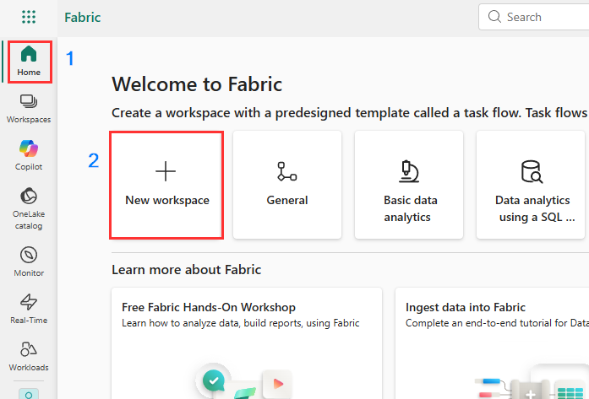
- In the Create a workspace tab, enter the following details and click on the Apply button.
Name | wh_contoso
Description | This workspace contains all the artifacts for the data warehouse
Advanced | Under License mode, select Trial/Fabric Capacity
Storage format | Small semantic model storage format
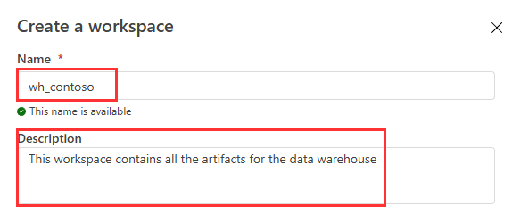
- Wait for the deployment to complete. When your new workspace opens, it should be empty.

Create a Warehouse in Microsoft Fabric
- In the wh_contoso workspace page, click on the + New item icon and select Warehouse under Store data.
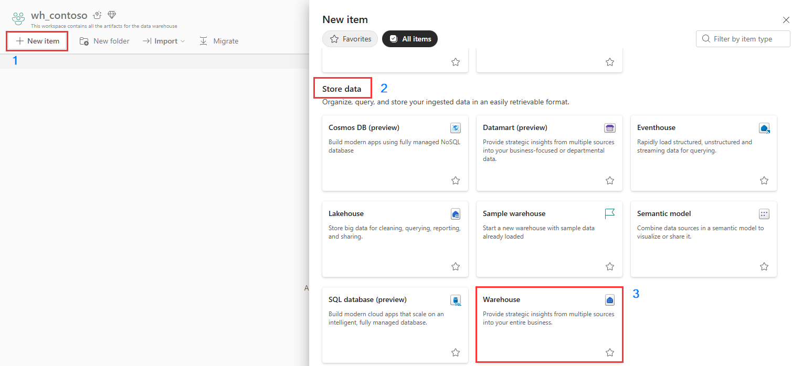
- On the New warehouse dialog, enter WideWorldImporters and click on the Create button.
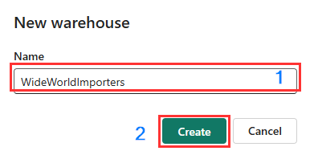
- When provisioning is complete, the WideWorldImporters warehouse landing page appears.
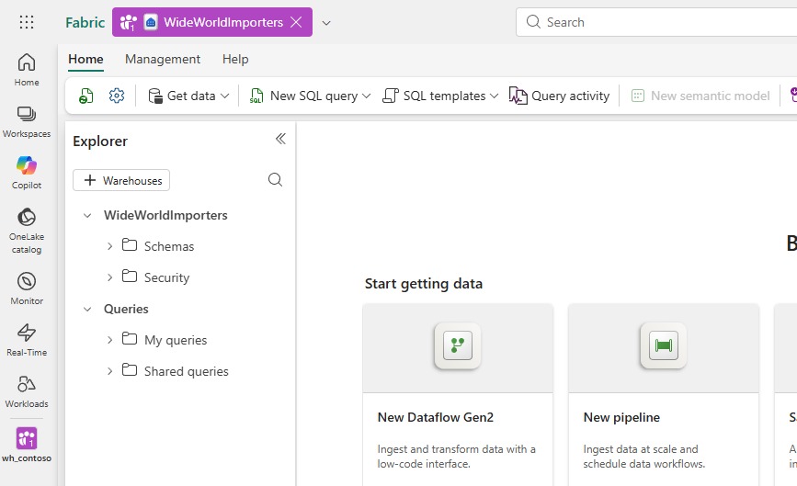

Exercise 2: Ingest data into a Warehouse in Microsoft Fabric
- Click Workspaces and Select the wh_contoso Workspace
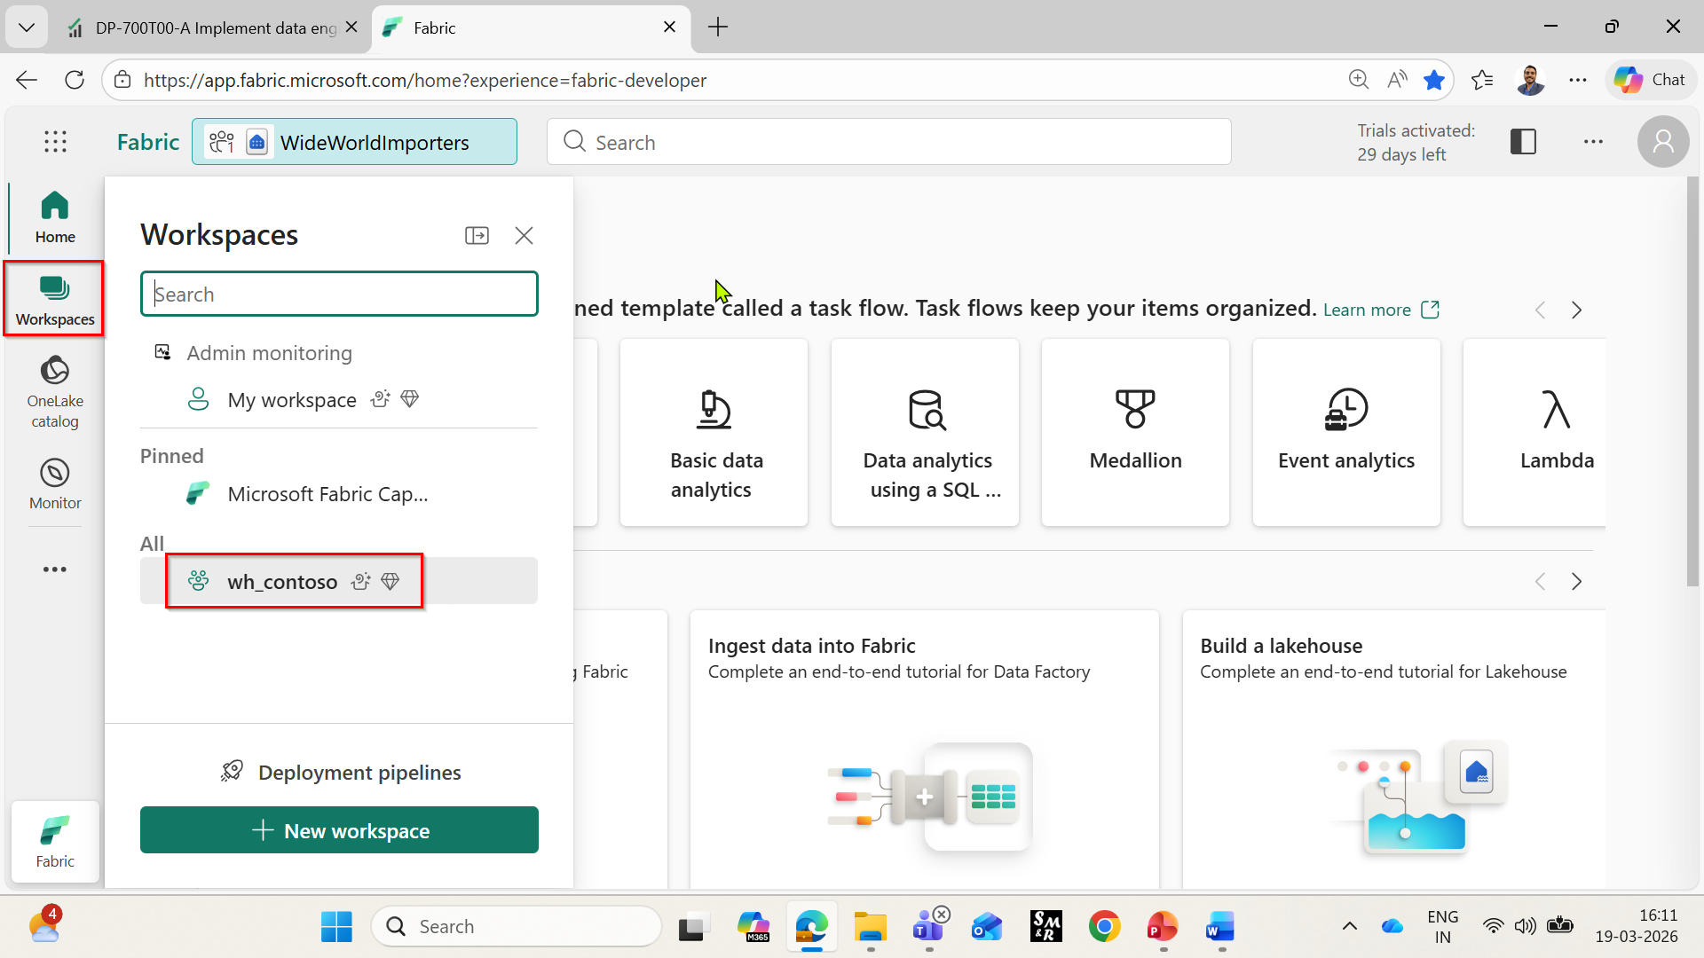
- Select New item.
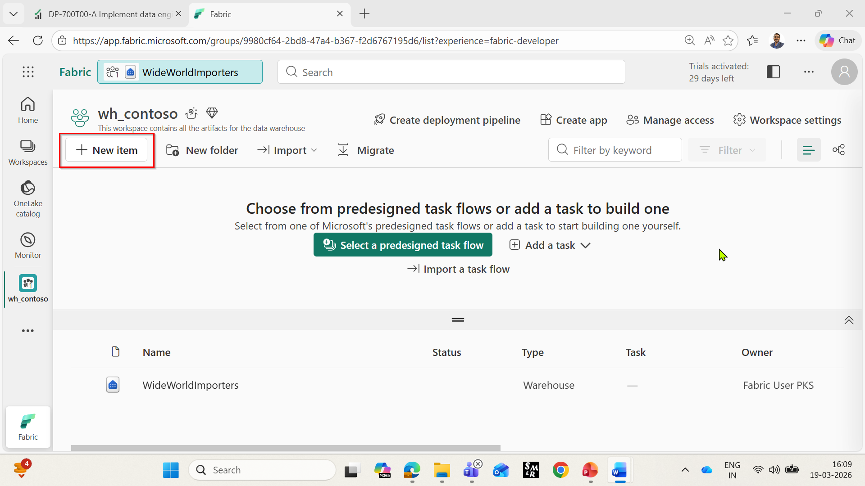
- Search for Pipeline and Select it
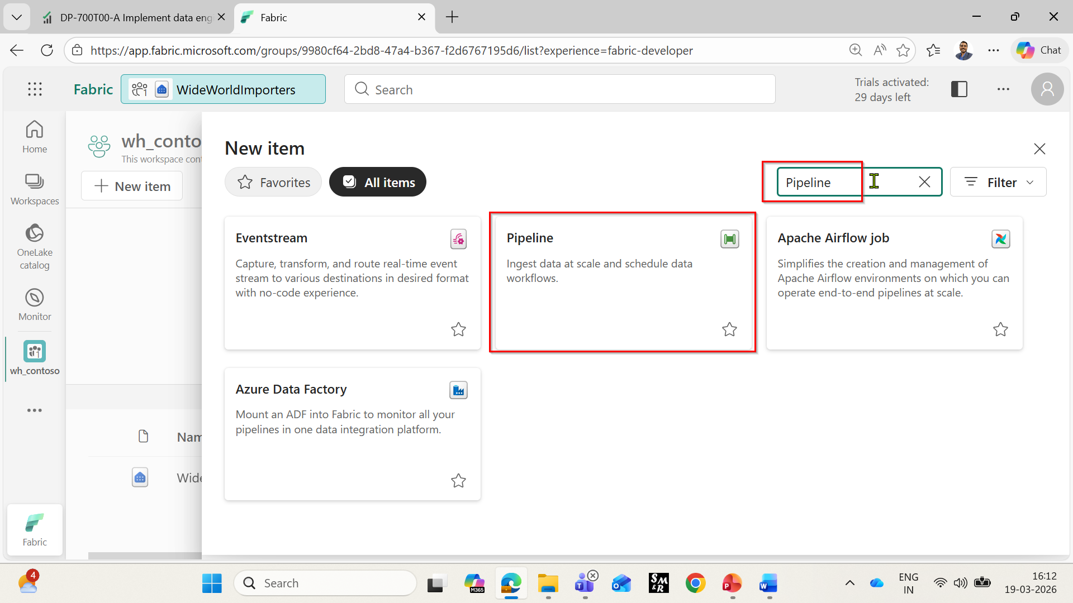
- On the New pipeline dialog box, in the Name field, enter Load Customer Data and click on the Create button.
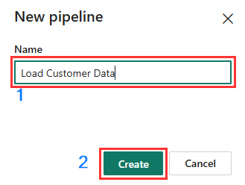
- In the Load Customer Data page, navigate to Build a pipeline to organize and move your data section and click on Pipeline activity. Navigate and select Copy data under Move &transform section.
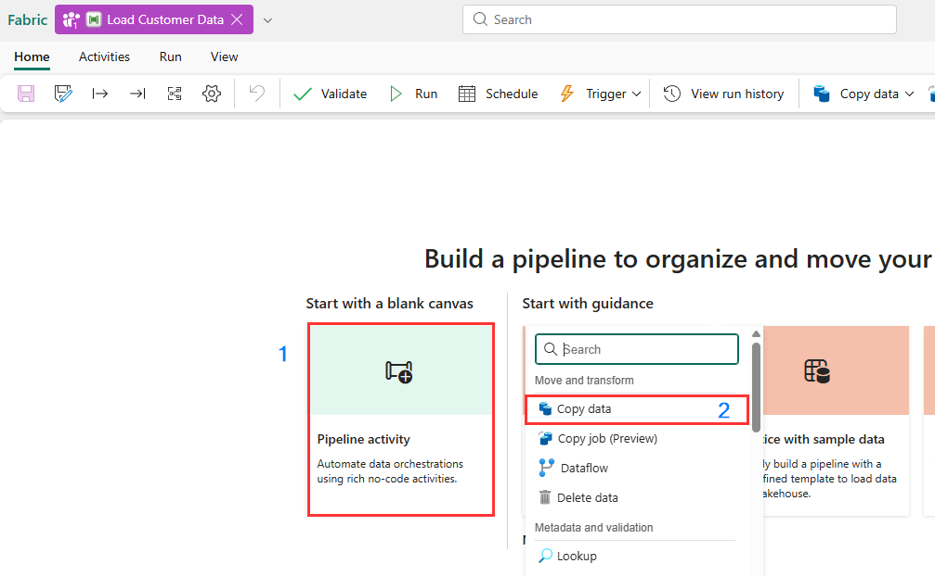
- Select the newly created Copy data 1 activity from the design canvas to configure it. Note: Drag the horizonal line in the design canvas to have a complete view of various features.
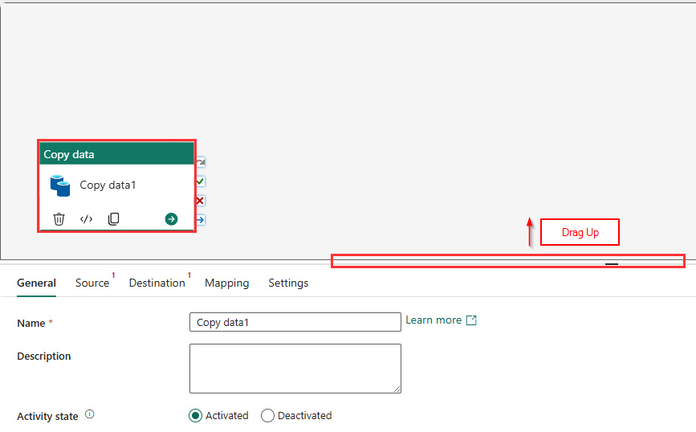
- On the General tab, in the Name field, enter Copy dimension_customer
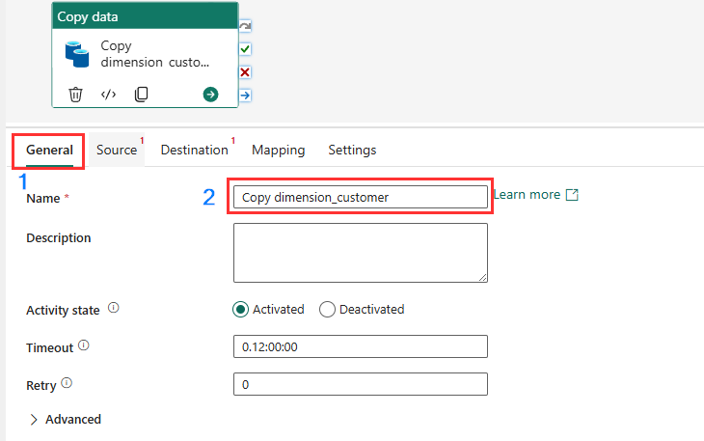

- On the Source page, select the Connection dropdown. Select Browse all to see all of the data sources you can choose from, including data sources in your local OneLake data hub.
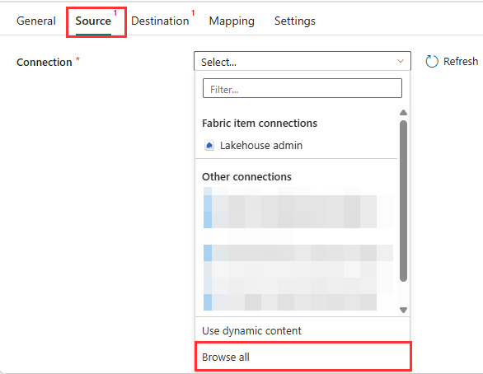
- On the Get data window, search Azure Blobs in, then click on the Azure Blobs button.
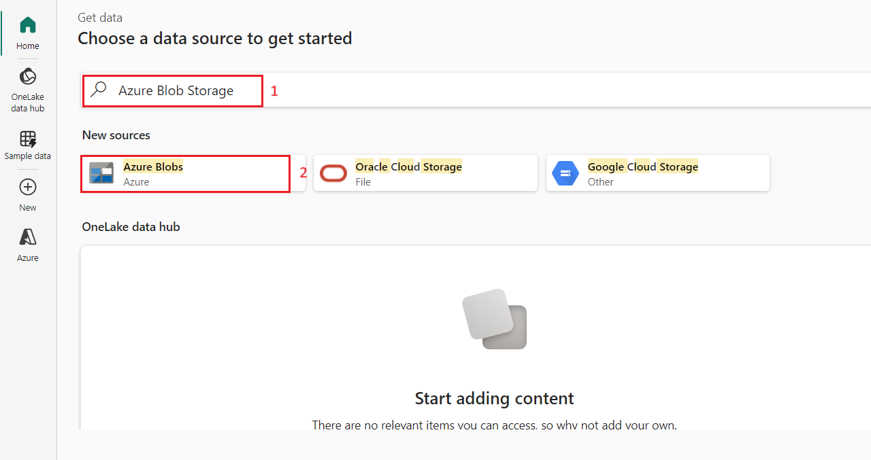
- On the Connection settings pane that appears on the right side, configure the following settings and click on the Connect button.
- In the Account name or URL, enter
https://fabrictutorialdata.blob.core.windows.net/sampledata/
- In the Connection credentials section, click on the dropdown under Connection, then select Create new connection.
- In Connection name field, enter Wide World Importers Public Sample
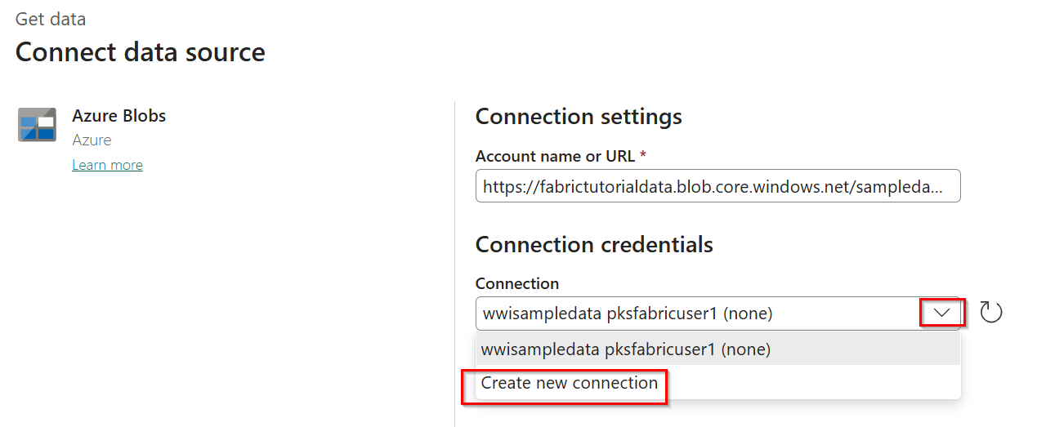
- Set the Authentication kind to Anonymous.
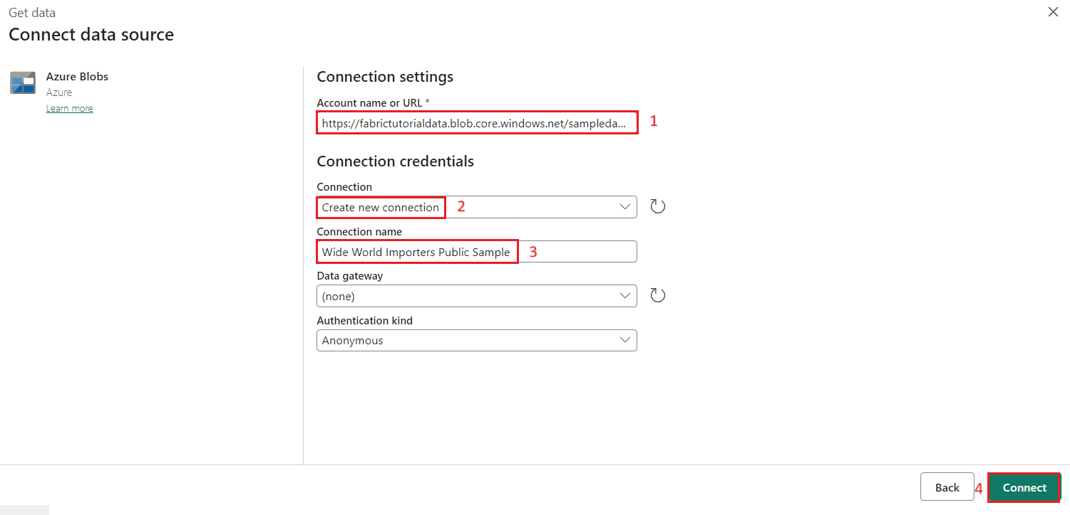
- In the File path text boxes, provide:
- Container: sampledata

- File path - Directory: WideWorldImportersDW/tables

- File path - File name: dimension_customer.parquet

- In the File format drop down, choose Parquet
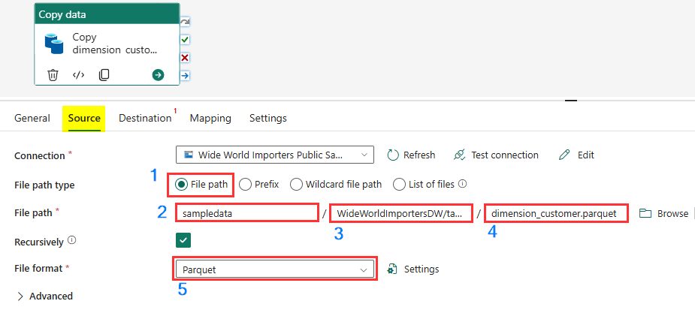
- Click on Preview data on the right side of File path setting to ensure that there are no errors and then click on close.
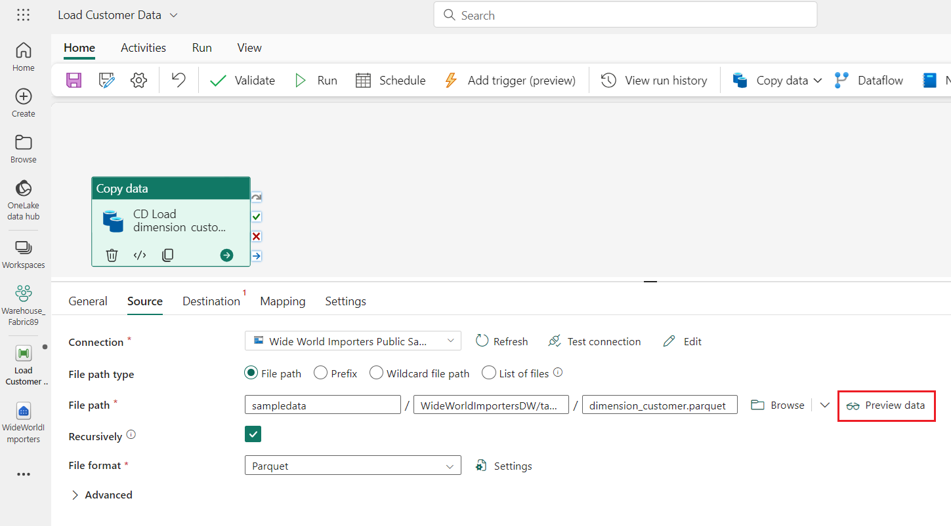

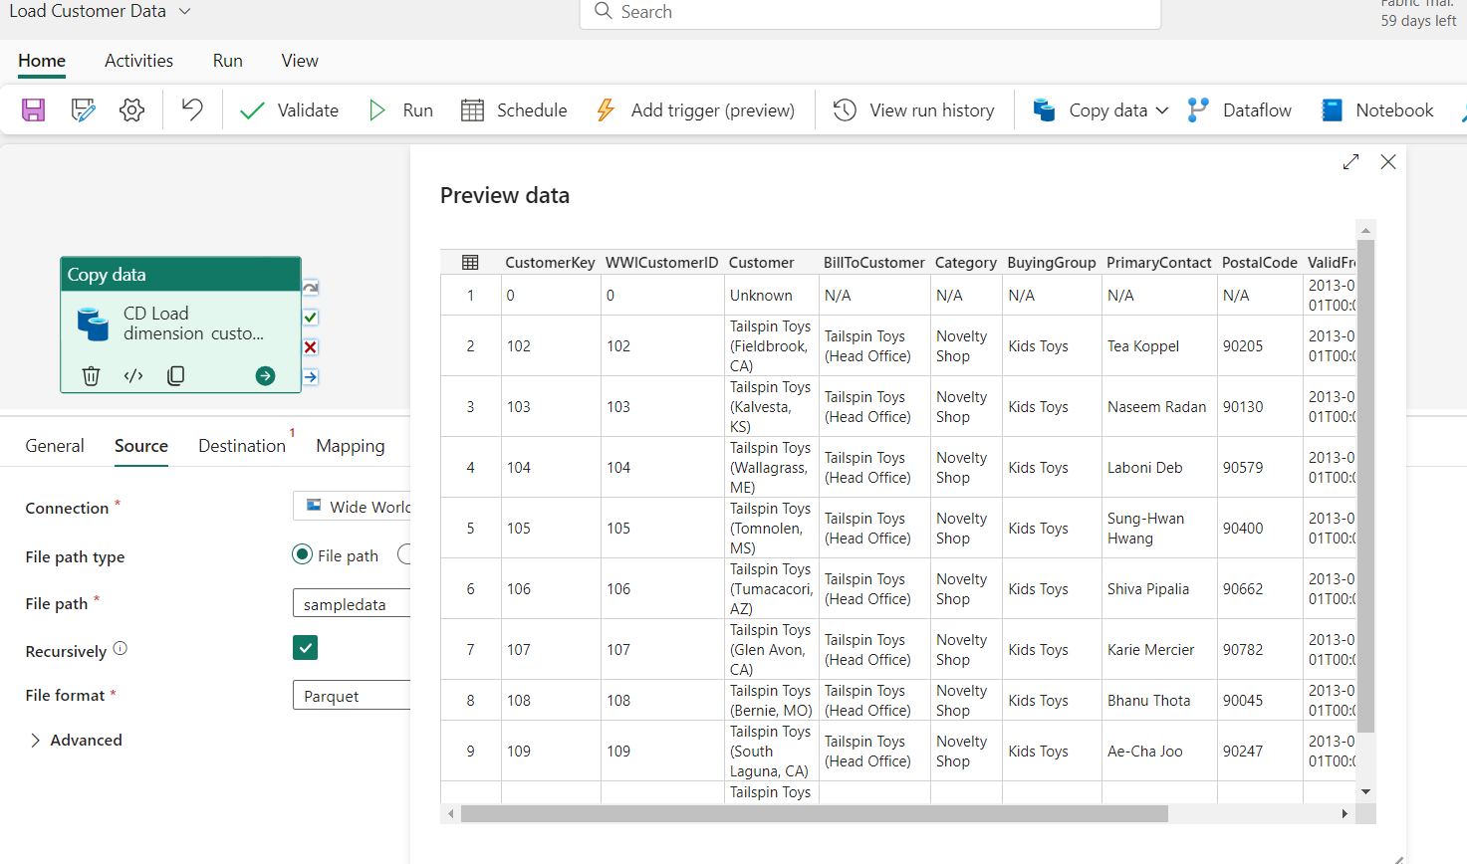
- On the Destination tab, select the Connection dropdown. Select Browse all, on Choose a destination page. Scroll down and select WideWorldImporters data warehouse.
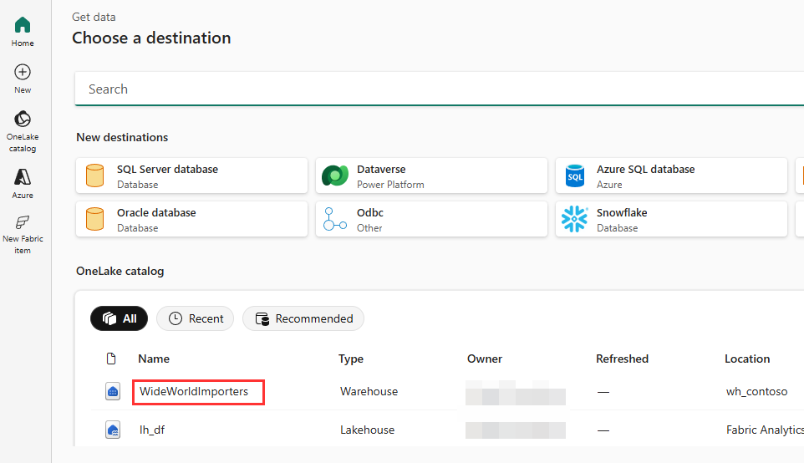
- On the Destination tab, ensure the following settings.
Connection - | Warehouse admin
Warehouse - | WideWorldImporters
Table option - | Auto create table.
Table - | Schema name: dbo  Table name: dimension_customer

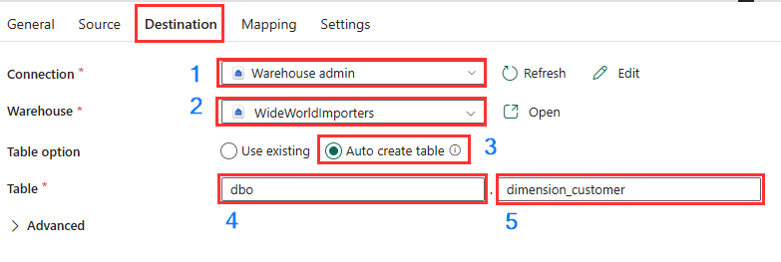
- From the ribbon, select Save and then Run.
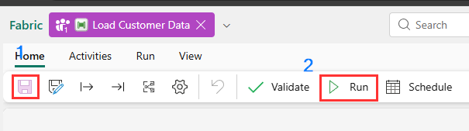
- Monitor the copy activity's progress on the Output page and wait for it to complete.
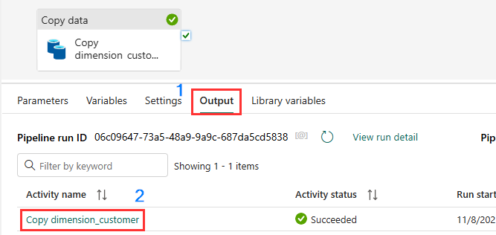

Exercise 3: Create tables in a Data Warehouse
- Click on wh_contoso workspace in the left-sided navigation bar and click on WideWorldImporters Warehouse as shown in the below image.
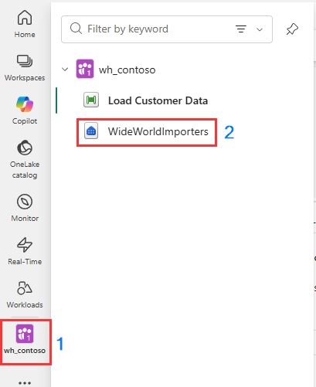
- On the WideWorldImporters page, go to the Home tab, select New SQL query.
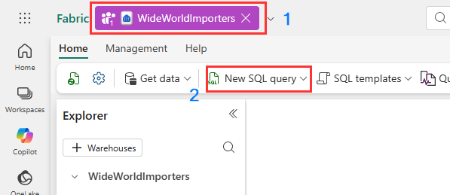
- In the query editor, paste the following code and select Run to execute the query
/*
1. Drop the dimension_city table if it already exists.
2. Create the dimension_city table.
3. Drop the fact_sale table if it already exists.
4. Create the fact_sale table.
*/
--dimension_city
DROP TABLE IF EXISTS [dbo].[dimension_city];
CREATE TABLE [dbo].[dimension_city]
(
[CityKey] [int] NULL,
[WWICityID] [int] NULL,
[City] [varchar](8000) NULL,
[StateProvince] [varchar](8000) NULL,
[Country] [varchar](8000) NULL,
[Continent] [varchar](8000) NULL,
[SalesTerritory] [varchar](8000) NULL,
[Region] [varchar](8000) NULL,
[Subregion] [varchar](8000) NULL,
[Location] [varchar](8000) NULL,
[LatestRecordedPopulation] [bigint] NULL,
[ValidFrom] [datetime2](6) NULL,
[ValidTo] [datetime2](6) NULL,
[LineageKey] [int] NULL
);

--fact_sale
DROP TABLE IF EXISTS [dbo].[fact_sale];
CREATE TABLE [dbo].[fact_sale]
(
[SaleKey] [bigint] NULL,
[CityKey] [int] NULL,
[CustomerKey] [int] NULL,
[BillToCustomerKey] [int] NULL,
[StockItemKey] [int] NULL,
[InvoiceDateKey] [datetime2](6) NULL,
[DeliveryDateKey] [datetime2](6) NULL,
[SalespersonKey] [int] NULL,
[WWIInvoiceID] [int] NULL,
[Description] [varchar](8000) NULL,
[Package] [varchar](8000) NULL,
[Quantity] [int] NULL,
[UnitPrice] [decimal](18, 2) NULL,
[TaxRate] [decimal](18, 3) NULL,
[TotalExcludingTax] [decimal](29, 2) NULL,
[TaxAmount] [decimal](38, 6) NULL,
[Profit] [decimal](18, 2) NULL,
[TotalIncludingTax] [decimal](38, 6) NULL,
[TotalDryItems] [int] NULL,
[TotalChillerItems] [int] NULL,
[LineageKey] [int] NULL,
[Month] [int] NULL,
[Year] [int] NULL,
[Quarter] [int] NULL
);

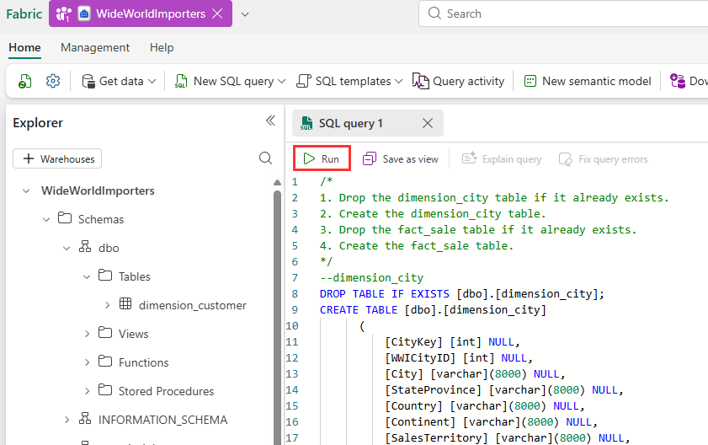

- To save this query, right-click on the SQL query 1 tab just above the editor and select Rename.
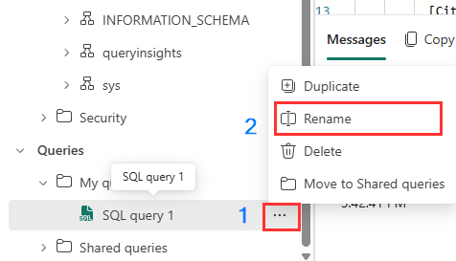
- In the Rename dialog box, under Name field, enter Create Tables to change the name of SQL query 1. Then, click on the Rename button.
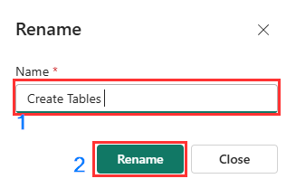
- Validate the table was created successfully by selecting the refresh icon button on the ribbon. In the Explorer pane, you’ll see the fact_sale table and dimension_city table.
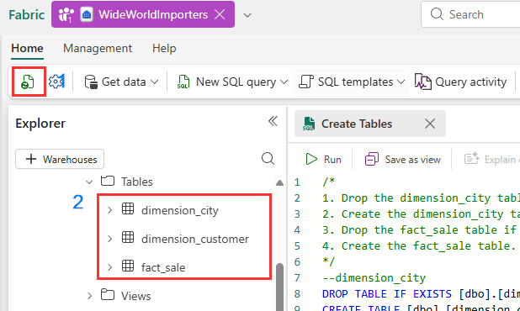

Load data using T-SQL
Now that you know how to build a data warehouse, load a table, and generate a report, it's time to extend the solution by exploring other methods for loading data.
- On the WideWorldImporters page, go to the Home tab, select New SQL query.
- In the query editor, paste the following code, then click on Run to execute the query.
--Copy data from the public Azure storage account to the dbo.dimension_city table.
COPY INTO [dbo].[dimension_city]
FROM 'https://fabrictutorialdata.blob.core.windows.net/sampledata/WideWorldImportersDW/tables/dimension_city.parquet'
WITH (FILE_TYPE = 'PARQUET');

--Copy data from the public Azure storage account to the dbo.fact_sale table.
COPY INTO [dbo].[fact_sale]
FROM 'https://fabrictutorialdata.blob.core.windows.net/sampledata/WideWorldImportersDW/tables/fact_sale.parquet'
WITH (FILE_TYPE = 'PARQUET');
- After the query is completed, review the messages, which indicates the number of rows that were loaded into the dimension_city and fact_sale tables respectively.
- Load the data preview to validate the data loaded successfully by selecting on the fact_sale table in the Explorer.
- Rename the query. Right-click on SQL query 1 in the Explorer, then select Rename. In the Rename dialog box, under the Name field, enter Load Tables
- Then, click on Rename button.

Exercise 4: Clone a table using T-SQL in Microsoft Fabric
Create a table clone within the same schema in a warehouse
This task guides you through creating a table clone in Warehouse in Microsoft Fabric, using the CREATE TABLE AS CLONE OF T-SQL syntax.
- Create a table clone within the same schema in a warehouse.
- On the WideWorldImporters page, go to the Home tab, select New SQL query.
- In the query editor, paste the following code to create clones of the dbo.dimension_city and dbo.fact_sale tables.
--Create a clone of the dbo.dimension_city table.
CREATE TABLE [dbo].[dimension_city1] AS CLONE OF [dbo].[dimension_city];

--Create a clone of the dbo.fact_sale table.
CREATE TABLE [dbo].[fact_sale1] AS CLONE OF [dbo].[fact_sale];

- Select Run to execute the query. The query takes a few seconds to execute. After the query is completed, the table clones dimension_city1 and fact_sale1 will be created.
- Load the data preview to validate the data loaded successfully by selecting on the dimension_city1 table in the Explorer.
- Right-click on SQL query that you’ve created to clone the tables in the Explorer and select Rename.
- In the Rename dialog box, under the Name field, enter Clone Table, then click on the Rename button.
- Click on the Refresh icon in the command bar below the Home tab.

Create a table clone across schemas within the same warehouse
- On the WideWorldImporters page, go to the Home tab, select New SQL query.
- Create a new schema within the WideWorldImporter warehouse named dbo1. Copy paste and run the following T-SQL code as shown in the below image:
CREATE SCHEMA dbo1;
- In the query editor, remove the existing code and paste the following to create clones of the dbo.dimension_city and dbo.fact_sale tables in the dbo1 schema.

--Create a clone of the dbo.dimension_city table in the dbo1 schema.
CREATE TABLE [dbo1].[dimension_city1] AS CLONE OF [dbo].[dimension_city];

--Create a clone of the dbo.fact_sale table in the dbo1 schema.
CREATE TABLE [dbo1].[fact_sale1] AS CLONE OF [dbo].[fact_sale];

- Select Run to execute the query. The query takes a few seconds to execute.
- After the query is completed, clones dimension_city1 and fact_sale1 are created in the dbo1 schema.
- Load the data preview to validate the data loaded successfully by selecting on the dimension_city1 table under dbo1 schema in the Explorer.
- Rename the query for reference later. Right-click on SQL query 1 in the Explorer and select Rename.
- In the Rename dialog box, under the Name field, enter Clone Table in another schema. Then, click on Rename button.
- Click on the Refresh icon in the command bar below the Home tab.

Exercise 5: Transform data using a stored procedure
Learn how to create and save a new stored procedure to transform data.
- On the WideWorldImporters page, go to the Home tab, select New SQL query.
- In the query editor, paste the following code to create the stored procedure dbo.populate_aggregate_sale_by_city. This stored procedure will create and load the dbo.aggregate_sale_by_date_city table in a later step.
--Drop the stored procedure if it already exists.
DROP PROCEDURE IF EXISTS [dbo].[populate_aggregate_sale_by_city]
GO

--Create the populate_aggregate_sale_by_city stored procedure.
CREATE PROCEDURE [dbo].[populate_aggregate_sale_by_city]
AS
BEGIN
--If the aggregate table already exists, drop it. Then create the table.
DROP TABLE IF EXISTS [dbo].[aggregate_sale_by_date_city];
CREATE TABLE [dbo].[aggregate_sale_by_date_city]
(
[Date] [DATETIME2](6),
[City] [VARCHAR](8000),
[StateProvince] [VARCHAR](8000),
[SalesTerritory] [VARCHAR](8000),
[SumOfTotalExcludingTax] [DECIMAL](38,2),
[SumOfTaxAmount] [DECIMAL](38,6),
[SumOfTotalIncludingTax] [DECIMAL](38,6),
[SumOfProfit] [DECIMAL](38,2)
);

--Reload the aggregated dataset to the table.
INSERT INTO [dbo].[aggregate_sale_by_date_city]
SELECT
FS.[InvoiceDateKey] AS [Date],
DC.[City],
DC.[StateProvince],
DC.[SalesTerritory],
SUM(FS.[TotalExcludingTax]) AS [SumOfTotalExcludingTax],
SUM(FS.[TaxAmount]) AS [SumOfTaxAmount],
SUM(FS.[TotalIncludingTax]) AS [SumOfTotalIncludingTax],
SUM(FS.[Profit]) AS [SumOfProfit]
FROM [dbo].[fact_sale] AS FS
INNER JOIN [dbo].[dimension_city] AS DC
ON FS.[CityKey] = DC.[CityKey]
GROUP BY
FS.[InvoiceDateKey],
DC.[City],
DC.[StateProvince],
DC.[SalesTerritory]
ORDER BY
FS.[InvoiceDateKey],
DC.[StateProvince],
DC.[City];
END

- Right-click on SQL query that you’ve created to clone the tables in the Explorer and select Rename.
- In the Rename dialog box, under the Name field, enter Create Aggregate Procedure, then click on the Rename button.
- In the Explorer tab, verify that you can see the newly created stored procedure by expanding the StoredProcedures node under the dbo schema.
- On the WideWorldImporters page, go to the Home tab, select New SQL query.
- In the query editor, paste the following code. This T-SQL executes dbo.populate_aggregate_sale_by_city to create the dbo.aggregate_sale_by_date_city table. Run the query
--Execute the stored procedure to create the aggregate table.
EXEC [dbo].[populate_aggregate_sale_by_city];
- To save this query for reference later, right-click on the query tab just above the editor and select Rename.
- In the Rename dialog box, under the Name field, enter Run Create Aggregate Procedure, then click on the Rename button.
- Select the Refresh icon on the ribbon.
- In the Object Explorer tab, load the data preview to validate the data loaded successfully by selecting on the aggregate_sale_by_city table in the Explorer.

Exercise 6: Time travel using T-SQL at statement level
- On the WideWorldImporters page, go to the Home tab, select New SQL query.
- In the query editor, paste the following code to create the view Top10CustomerView. Select Run to execute the query.
CREATE VIEW dbo.Top10CustomersView
AS
SELECT TOP (10)
FS.[CustomerKey],
DC.[Customer],
SUM(FS.TotalIncludingTax) AS TotalSalesAmount
FROM
[dbo].[dimension_customer] AS DC
INNER JOIN
[dbo].[fact_sale] AS FS ON DC.[CustomerKey] = FS.[CustomerKey]
GROUP BY
FS.[CustomerKey],
DC.[Customer]
ORDER BY
TotalSalesAmount DESC;

- In the Explorer, verify that you can see the newly created view Top10CustomersView by expanding the View node under dbo schema.
- To save this query for reference later, right-click on the query tab just above the editor and select Rename.
- In the Rename dialog box, under the Name field, enter Top10CustomersView, then click on the Rename button.
- Create another new query, like Step 1.
From the Home tab of the ribbon, select New SQL query.
- In the query editor, paste the following code. This updates the TotalIncludingTax column value to 200000000 for the record which has the SaleKey value of 22632918. Select Run to execute the query.

/*Update the TotalIncludingTax value of the record with SaleKey value of 22632918*/
UPDATE [dbo].[fact_sale]
SET TotalIncludingTax = 200000000
WHERE SaleKey = 22632918;
- In the query editor, paste the following code. The CURRENT_TIMESTAMP T-SQL function returns the current UTC timestamp as a datetime. Select Run to execute the query.
SELECT CURRENT_TIMESTAMP;
- Copy the timestamp value returned to your clipboard.
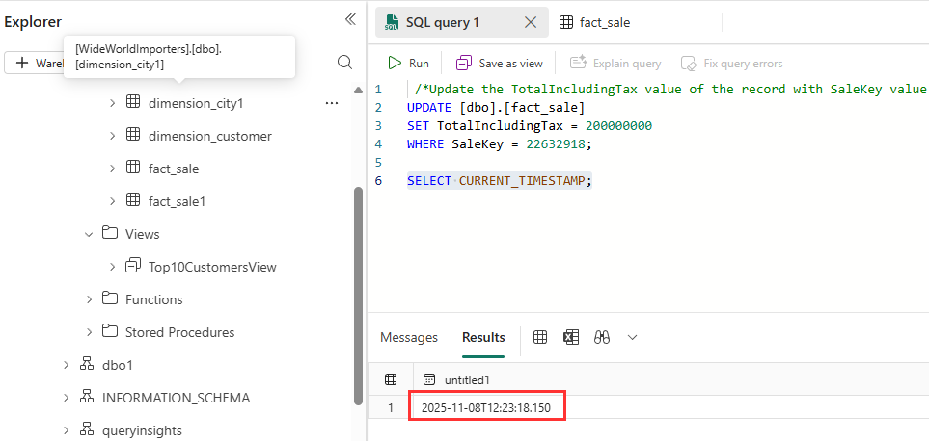
- The following example returns the list of top ten customers by TotalIncludingTax, including the new value for SaleKey 22632918.
- Replace the existing code in the query editor and paste the following code make sure to replace the timestamp value with the current timestamp value obtained from the prior step. Select Run to execute the query.
/*View of Top10 Customers as of today after record updates*/
SELECT *
FROM [WideWorldImporters].[dbo].[Top10CustomersView]
OPTION (FOR TIMESTAMP AS OF '2025-11-08T12:23:18.150');

- Paste the following code in the query editor and replace the timestamp value to a time prior to executing the update script to update the TotalIncludingTax value. This would return the list of top ten customers before the TotalIncludingTax was updated for SaleKey 22632918. Select Run to execute the query.
/*View of Top10 Customers as of today before record updates*/
SELECT *
FROM [WideWorldImporters].[dbo].[Top10CustomersView]
OPTION (FOR TIMESTAMP AS OF ‘2025-11-08T12:20:18.150');

Exercise 7: Create a query with the visual query builder
Use the visual query builder
Create and save a query with the visual query builder in the Microsoft Fabric portal.
- In the WideWolrdImporters warehouse page, from the Home tab of the ribbon, Select the Drop down of New SQL query and select New visual query.
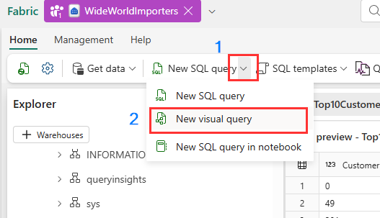

- Right-click on fact_sale and select Insert into canvas
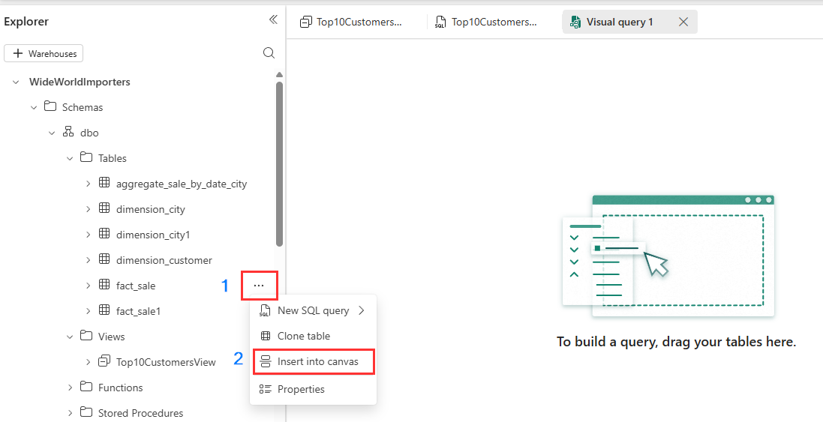

- Navigate to query design pane transformations ribbon and limit the dataset size by clicking on Reduce rows dropdown, then click on Keep top rows as shown in the below image.
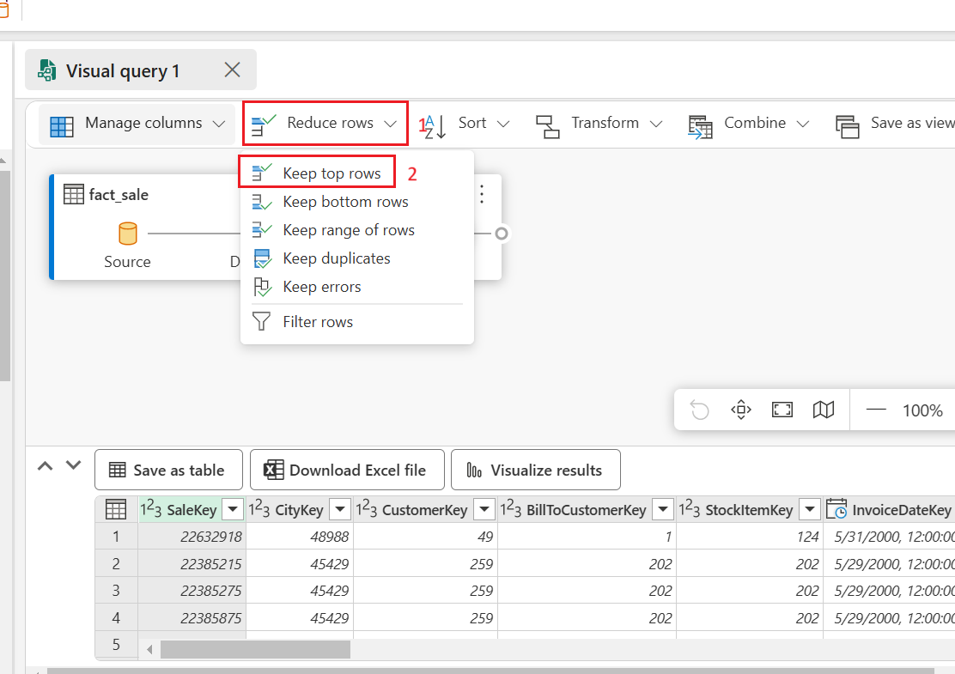
- In the Keep top rows dialog box, enter 10000 and Select OK.
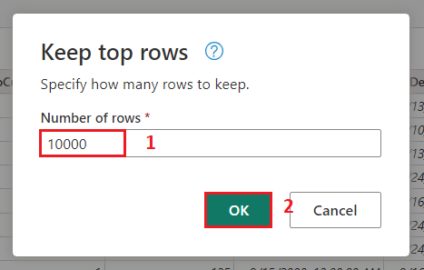

- Right-click on dimension_city and select Insert into canvas

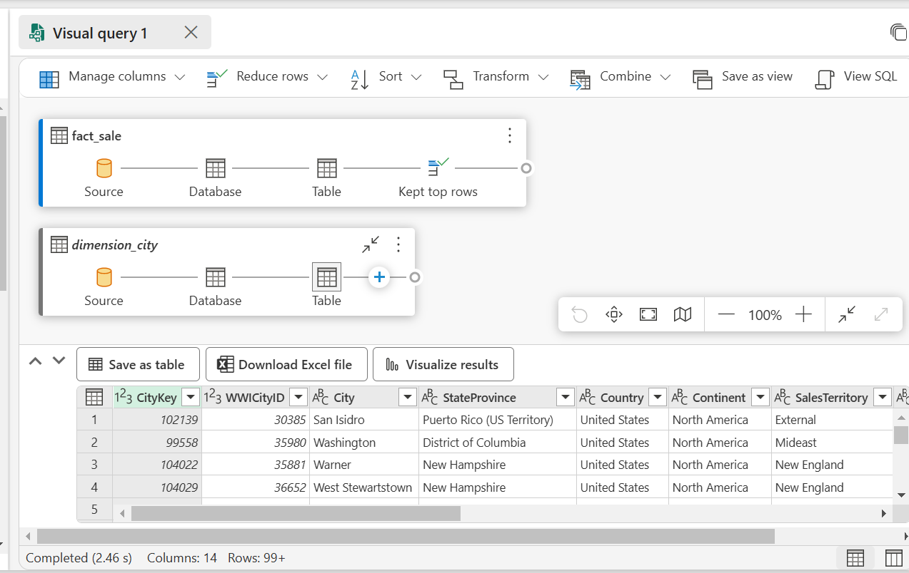
- From the transformations ribbon, select the dropdown beside Combine and select Merge queries as new as shown in the below image.
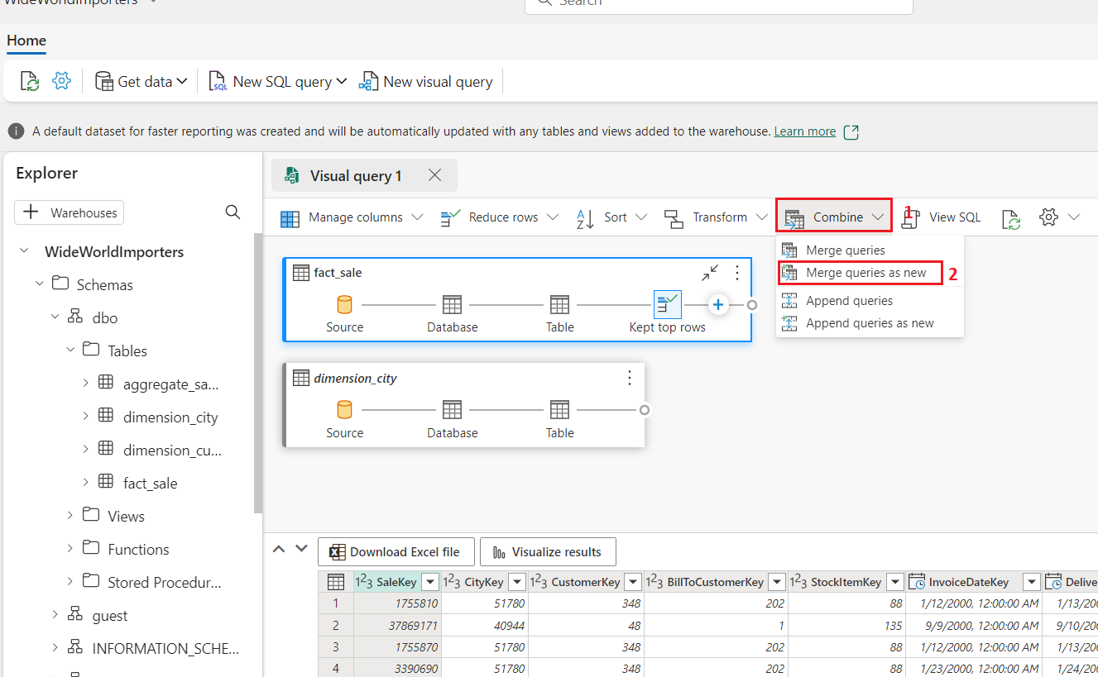
- On the Merge settings page enter the following details.
- In the Left table for merge dropdown, choose dimension_city
- In the Right table for merge dropdown, choose fact_sale (use horizontal and vertical scroll bar)
- Select the CityKey field in the dimension_city table by selecting on the column name in the header row to indicate the join column.
- Select the CityKey field in the fact_sale table by selecting on the column name in the header row to indicate the join column.
- In the Join kind diagram selection, choose Inner and click on the Ok button.
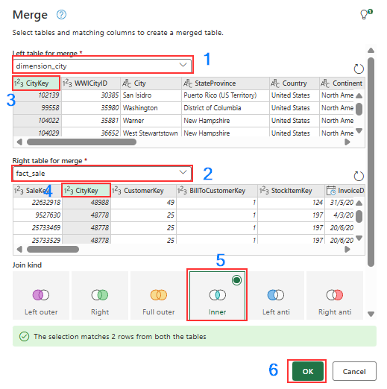
- With the Merge step selected, select the Expand button beside fact_sale on the header of the data grid as shown in the below image, then select the columns TaxAmount, Profit, TotalIncludingTax and select Ok.
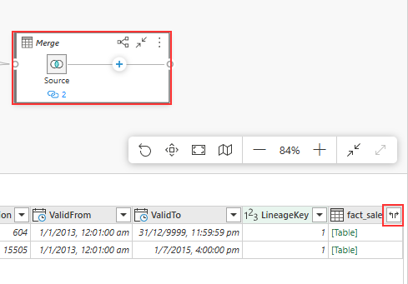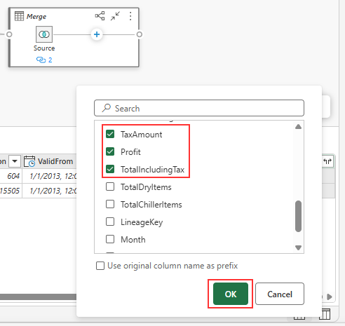
- In the transformations ribbon, click on the dropdown beside Transform, then select Group by.
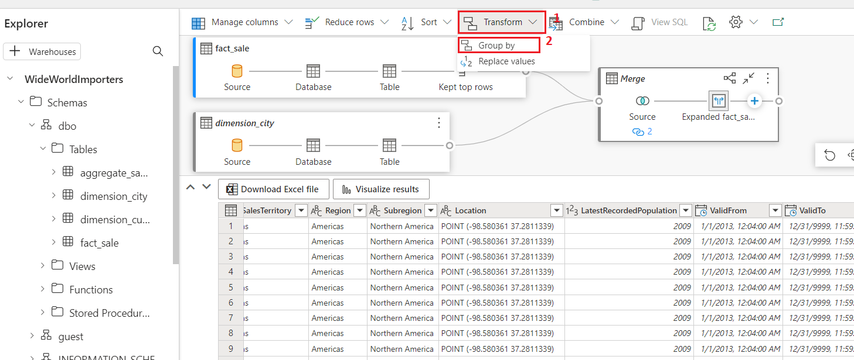
- On the Group by settings page, enter the following details.
- Select Advanced radio button.
- Under Group by select the following:
i. Country
ii. StateProvince
iii. City
- In the New column name, enter SumOfTaxAmount
In Operation column field, select Sum
Then under Column field, select TaxAmount.
Click on Add aggregation to add more aggregate column and operation.

- In the New column name , enter SumOfProfit
In Operation colum field, select Sum
Then under Column field, select Profit.
Click on Add aggregation to add more aggregate column and operation.

- In the New column name, enter SumOfTotalIncludingTax
In Operation colum field, Select Sum
then under Column field, TotalIncludingTax.

- Click on the OK button
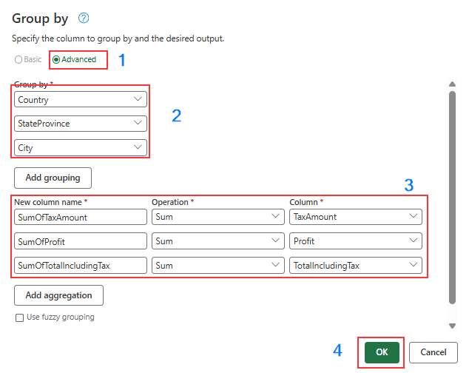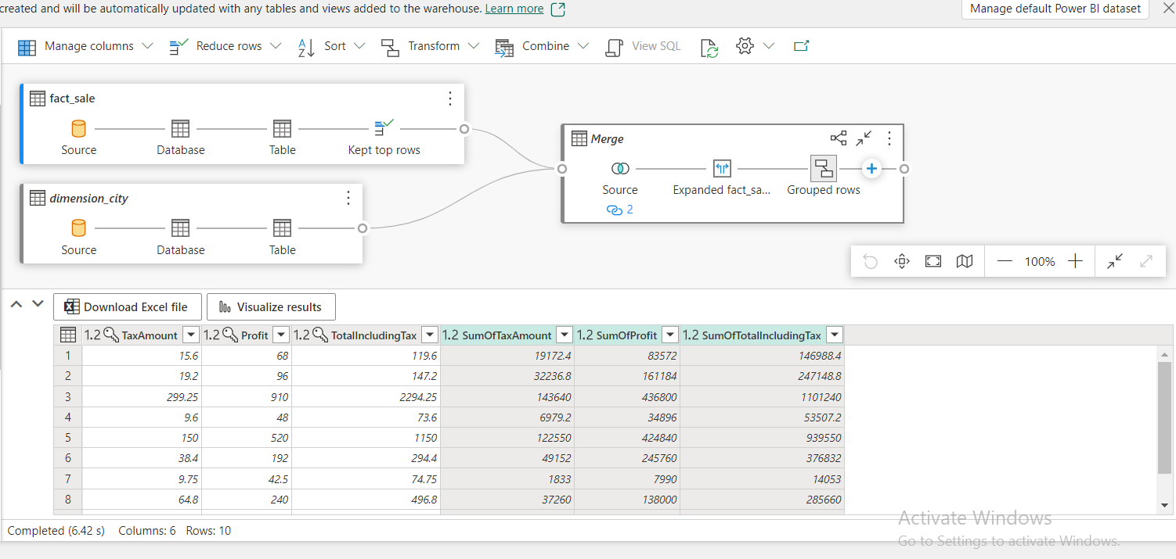
- In the explorer, navigate to Queries and right-click on Visual query 1 under Queries. Then, select Rename.
- Type Sales Summary to change the name of the query. Press Enter on the keyboard or select anywhere outside the tab to save the change.

Exercise 8: Query Warehouse Table with a notebook
Create a lakehouse shortcut and analyze data with a notebook
In this task, learn about how you can save your data once and then use it with many other services. Shortcuts can also be created to data stored in Azure Data Lake Storage and S3 to enable you to directly access delta tables from external systems.
First, we create a new lakehouse. To create a new lakehouse in your Microsoft Fabric workspace:
- Click on wh_contoso Workspace on the left-sided navigation menu and click on wh_contoso as shown.
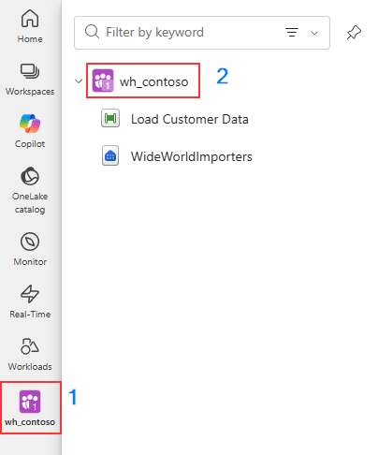
- On the wh_contoso home page, click +New item, and then select Lakehouse under Store data
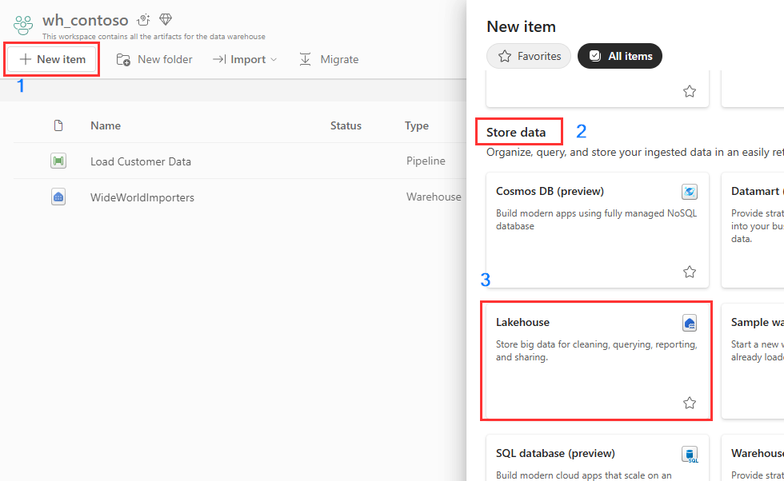
- In the Name field, enter ShortcutExercise, Uncheck Lakehouse Schemas and click on the Create button.
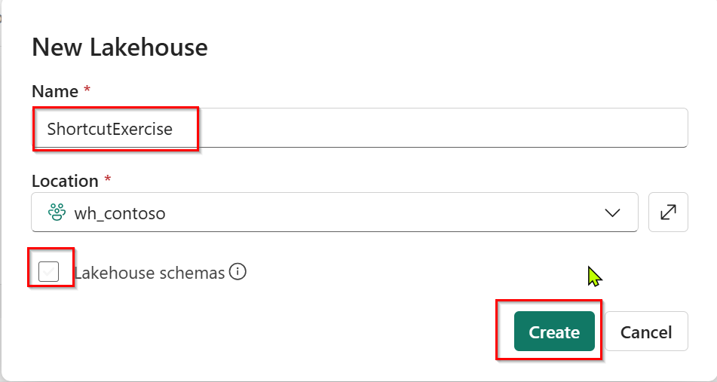
- The new lakehouse loads and the Explorer view opens up, with the Get data in your lakehouse menu. Under Load data in your lakehouse, select the New shortcut button.
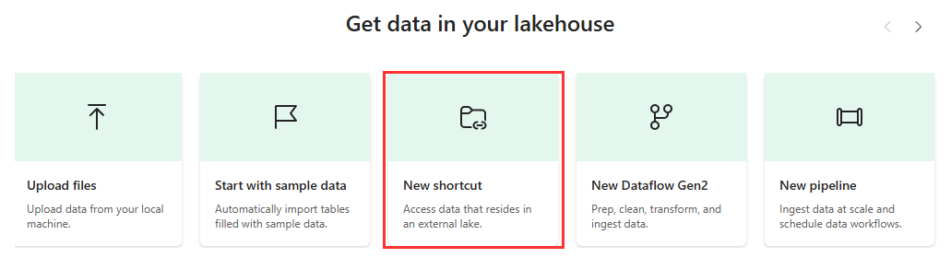
- In the New shortcut window, select Microsoft OneLake.
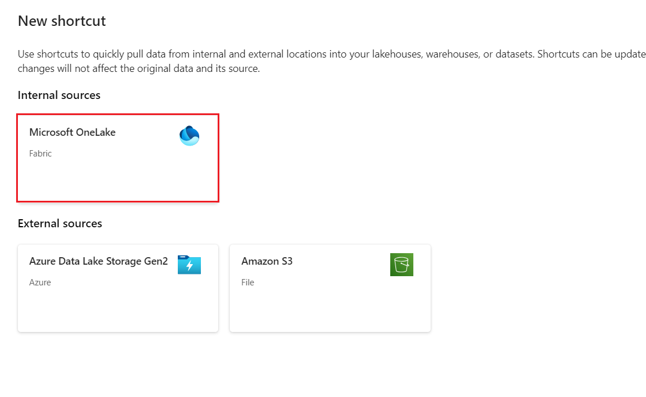
- In the Select a data source type window, carefully navigate and click on the Warehouse named WideWorldImporters that you’ve created previously, then click on the Next button.
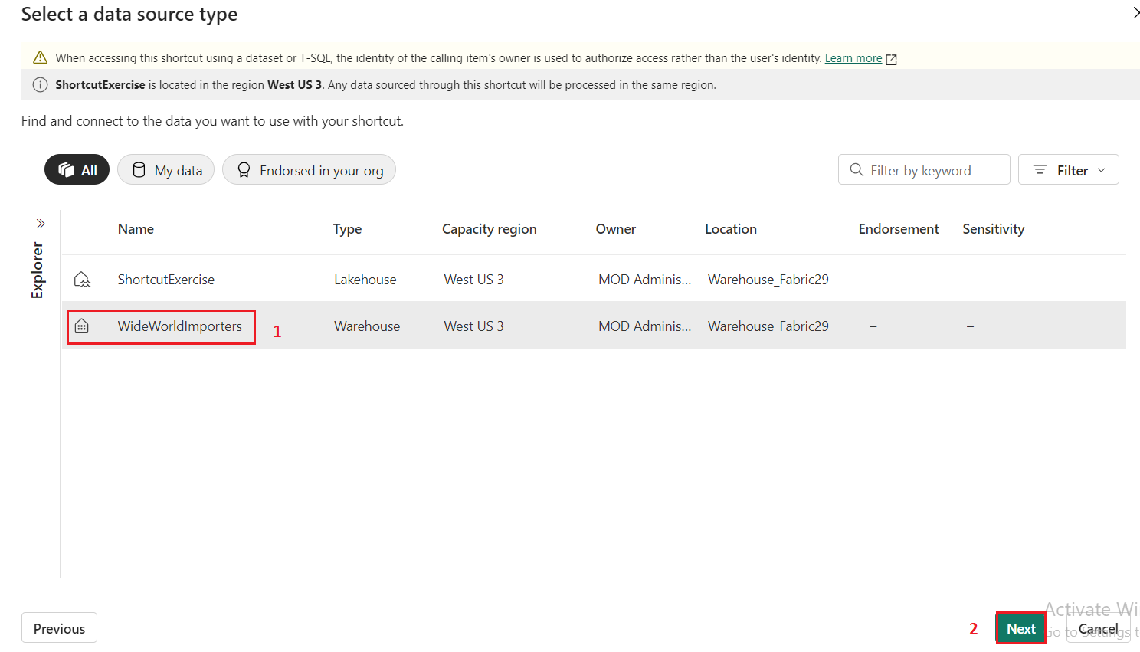
- In the OneLake object browser, expand Tables, then expand the dbo schema, and select the box beside dimension_customer. Select the Next button.
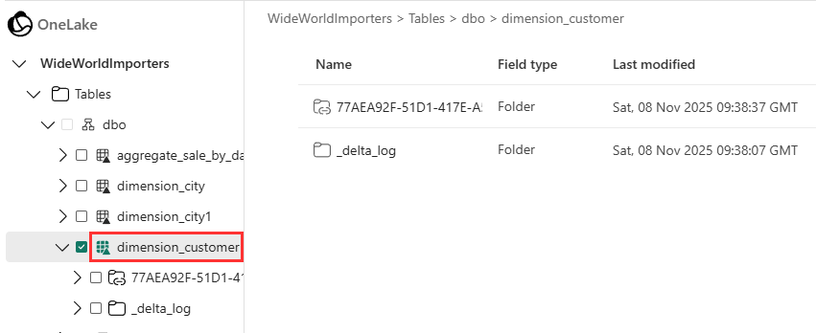
- In the New shortcut window, click on the Create button and click on the Close button.
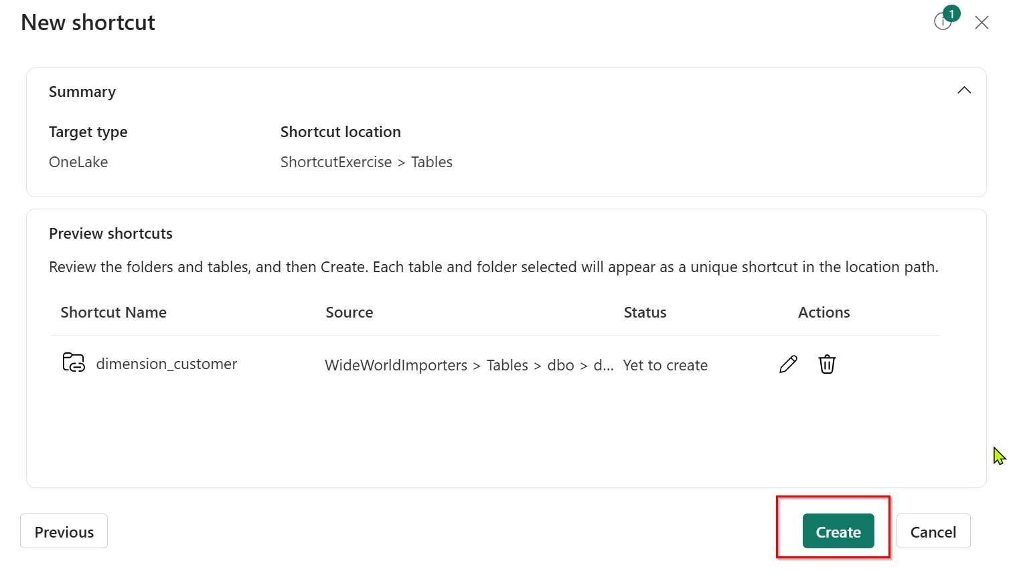
- Wait for a while and then click on the Refresh icon.
- Then, select the dimension_customer in the Table list to preview the data. Notice that the lakehouse is showing the data from the dimension_customer table from the Warehouse.
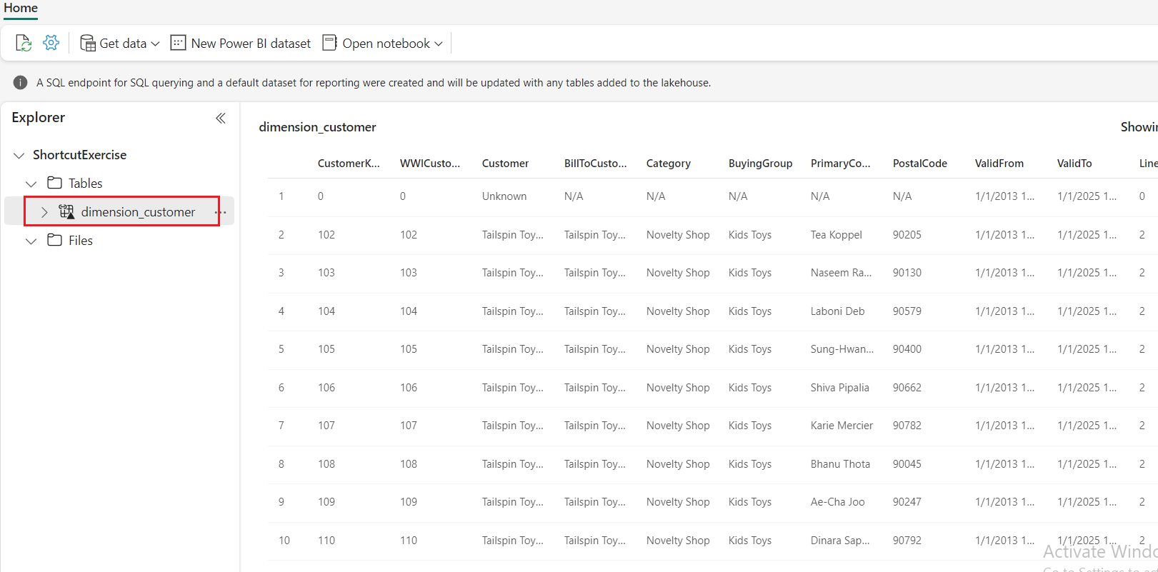

- Next, create a new notebook to query the dimension_customer table. In the Home ribbon, select the drop down for Open notebook and choose New notebook.
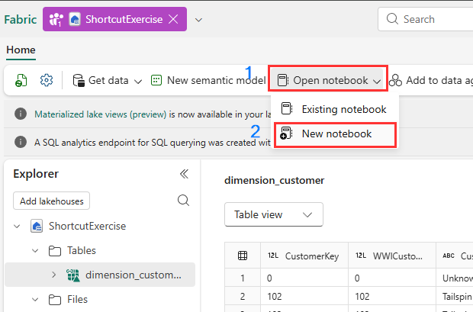
- Select, then drag the dimension_customer from the Tables list into the open notebook cell. You can see a PySpark query has been written for you to query all the data from ShortcutExercise.dimension_customer. This notebook experience is similar to Visual Studio Code Jupyter notebook experience. You can also open the notebook in VS Code.
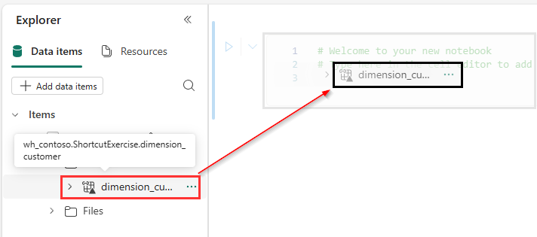
- In the Home ribbon, select the Run all button. Once the query is completed, you will see you can easily use PySpark to query the Warehouse tables.
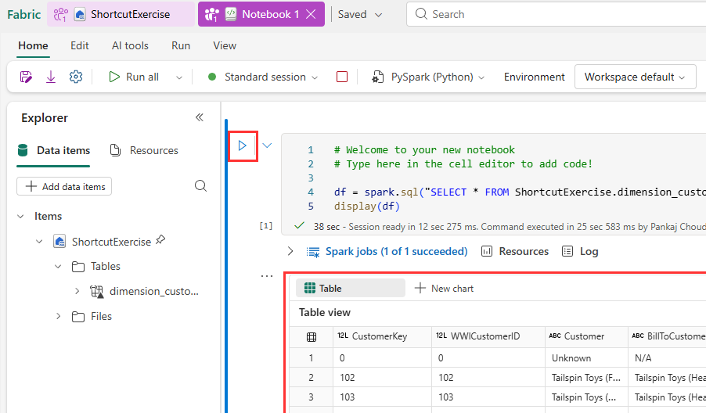

Exercise 9: Create cross-warehouse queries with the SQL query editor
Add multiple warehouses to the Explorer
In this task, learn about how you can easily create and execute T-SQL queries with the SQL query editor across multiple warehouse, including joining together data from a SQL Endpoint and a Warehouse in Microsoft Fabric.
- Navigation to WideWorldImporters warehouse.
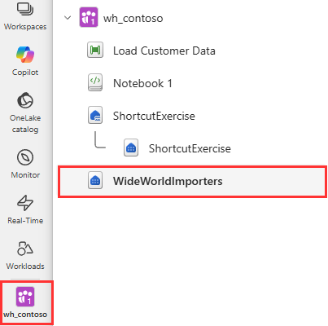
- In the WideWorldImporters page, under Explorer tab, select the + Warehouses button.
- In Add warehouses window, select ShortcutExercise and click on the Confirm button. Both warehouse experiences are added to the query.
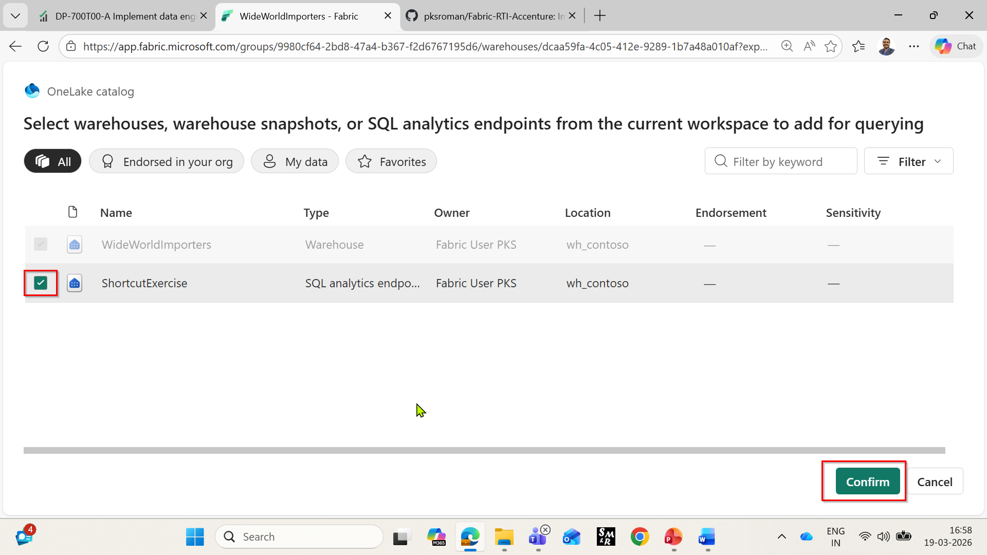
- Your selected warehouses now shown the same Explorer pane.
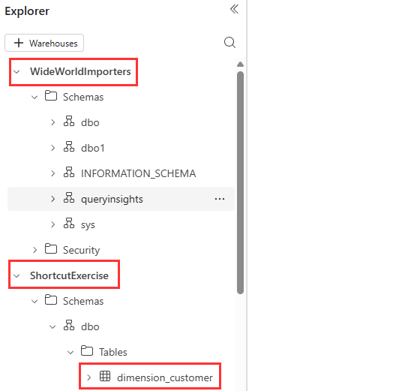

Execute a cross-warehouse query
In this example, you can see how easily you can run T-SQL queries across the WideWorldImporters warehouse and ShortcutExercise SQL Endpoint. You can write cross-database queries using three-part naming to reference the database.schema.table, as in SQL Server.
- From the Home tab of the ribbon, select New SQL query.
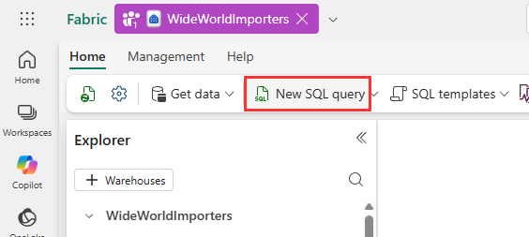
- In the query editor, copy and paste the following T-SQL code. Select the Run button to execute the query.
SELECT Sales.StockItemKey,
Sales.Description,
SUM(CAST(Sales.Quantity AS int)) AS SoldQuantity,
c.Customer
FROM
[dbo].[fact_sale] AS Sales,
[ShortcutExercise].[dbo].[dimension_customer] AS c
WHERE Sales.CustomerKey = c.CustomerKey
GROUP BY Sales.StockItemKey, Sales.Description, c.Customer;

- Rename the query for reference. Right-click on SQL query in the Explorer and select Rename.
- In the Rename dialog box, under the Name field, enter Cross-warehouse query, then click on the Rename button.

Optional Exercise: Create Semantic Model & Power BI reports
Create Power BI reports
In this task we learn how to create and save several types of Power BI reports.
- In the WideWorldImportes page, under the Home tab, select the New semantic model.
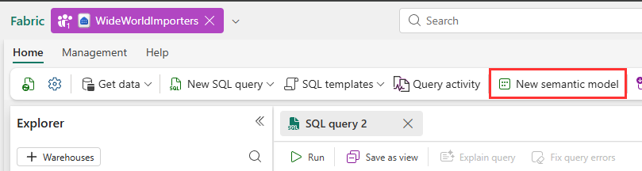
- On New semantic model dialog, Enter a semantic model name sm_wwi, workspace wh_contoso, under dbo schema select dimension_city and fact_sale tables.

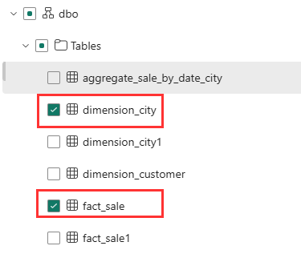
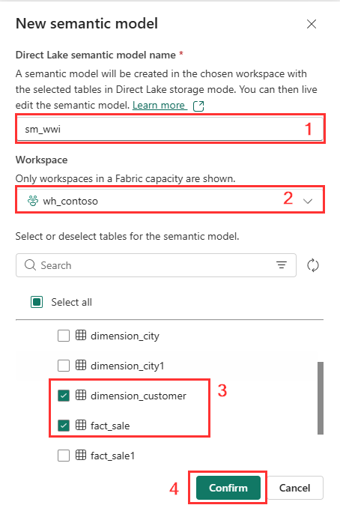
- Wait till the new sematic model created and then navigate to wh_contoso workspace and select sm_wwi semantic model.
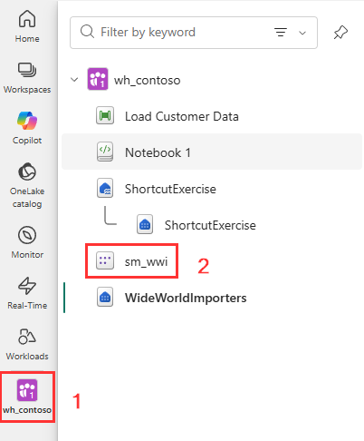
- On sm_wwi semantic model page, select open semantic model.
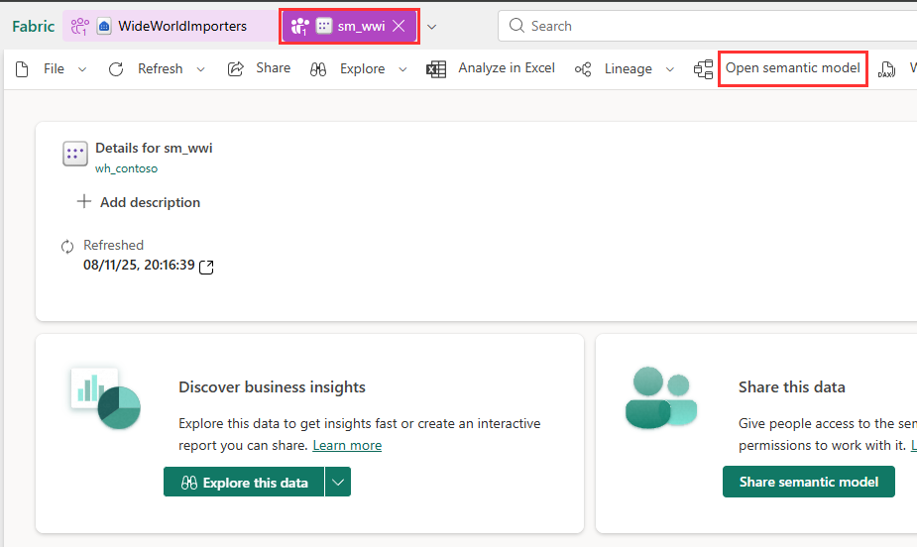
- A model view will open, now you are in edit mode. From top right corner in the model view, select Editing. This will convert the semantic model into large semantic model.
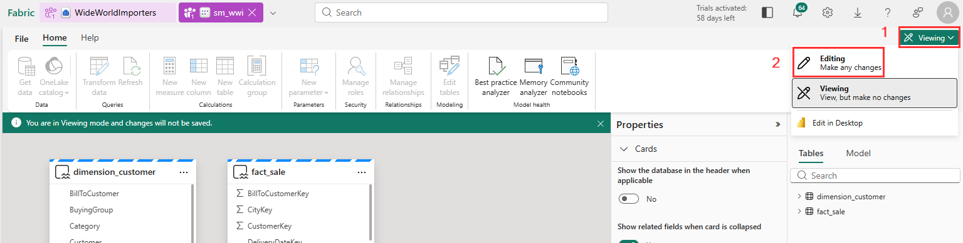
- From the fact_sale table, drag the CityKey field and drop it onto the CityKey field in the dimension_city table to create a relationship.
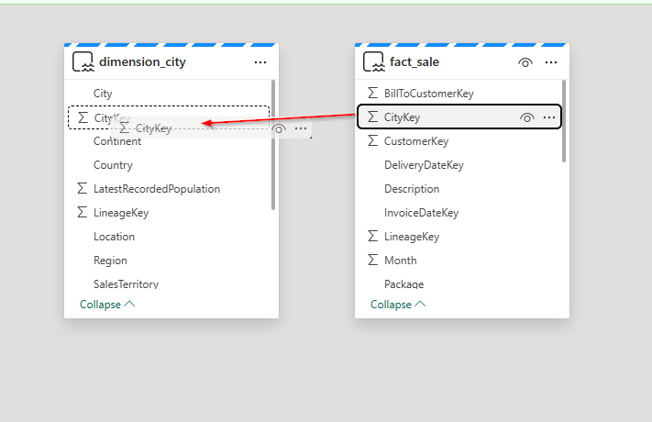
- On the Create Relationship settings:
  - Table 1 is populated with fact_sale and the column of CityKey.
  - Table 2 is populated with dimension_city and the column of CityKey.
  - Cardinality: select Many to one (*:1).
  - Cross filter direction: select Single.
  - Check the box for Make this relationship active.
  - Select Save.
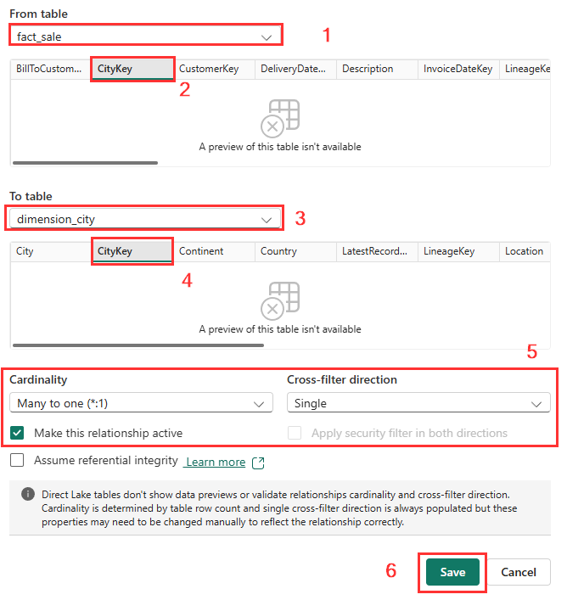
- From the File menu, select Create New report, this will open in new tab.
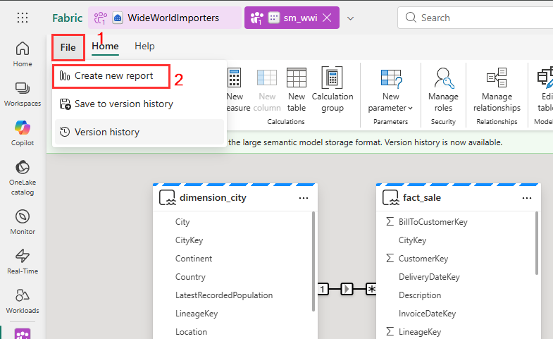

- In the Report page, under Visualizations, click to the Column chart icon to add a Column chart to your report.
  - On the Data pane, expand fact_sales and check the box next to Profit. This creates a column chart and adds the field to the Y-axis.
  - On the Data pane, expand dimension_city and check the box next to SalesTerritory. This adds the field to the X-axis.
  - Reposition and resize the column chart to take up the top left quarter of the canvas by dragging the anchor points on the corners of the visual.
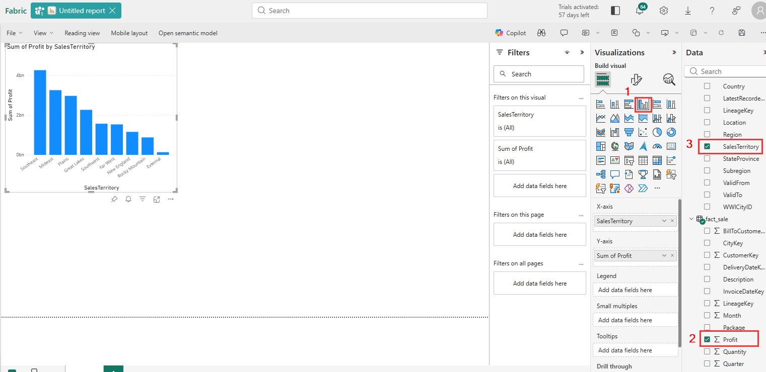
- Select anywhere on the blank canvas (or press the Esc key) so the column chart visual is no longer selected.
- Build a Table visual on the Visualizations pane, select the Table visual.
- From the Data pane, check the box next to SalesTerritory on the dimension_city table.
- From the Data pane, check the box next to StateProvince on the dimension_city table.
- From the Data pane, check the box next to Profit on the fact_sale table.
- From the Data pane, check the box next to TotalExcludingTax on the fact_sale table.
- Reposition and resize the column chart to take up the right half of the canvas by dragging the anchor points on the corners of the visual.
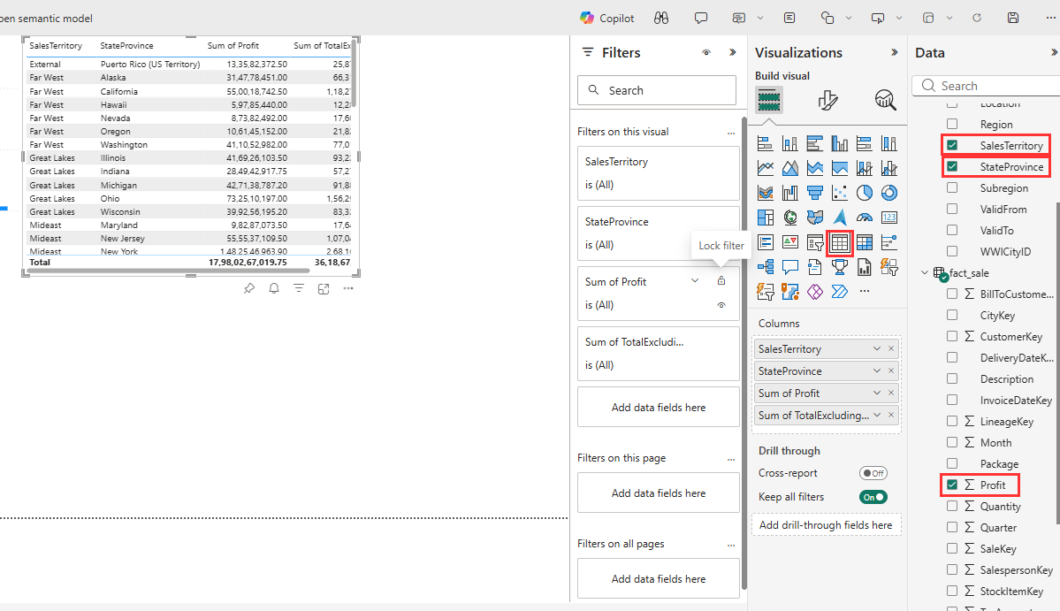
- In the Report page, from the ribbon, select File and select the Save.
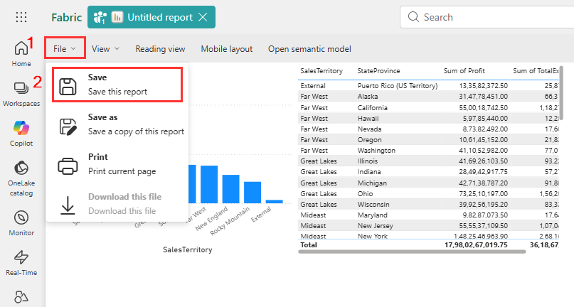
- In the Save your report dialog box, enter Sales Analysis as the name of your report and click on the Save button.
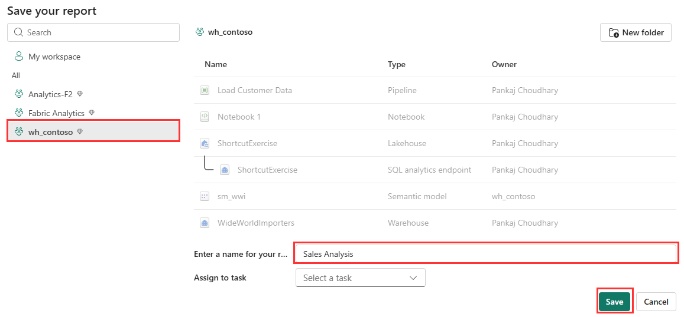
- You will see a notification stating Report saved.
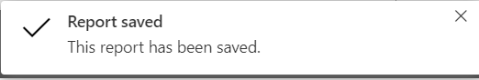

Optional Exercise: Build a report from the OneLake data hub
Learn how to build a report with the data you ingested into your Warehouse in the last step.
- Select the wh_contoso in the left navigation menu. From the item list, click on sm_wwi.
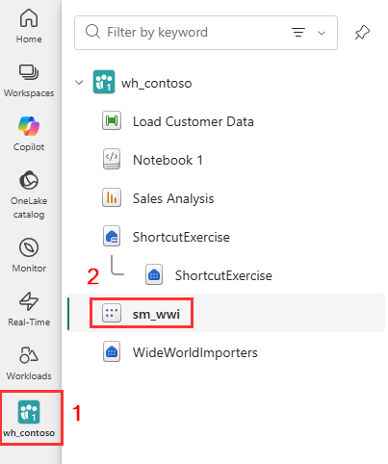
- In the Discover business insights section, select Auto-create a report. A report is generated from the fact_Sale table that was loaded in the previous section.
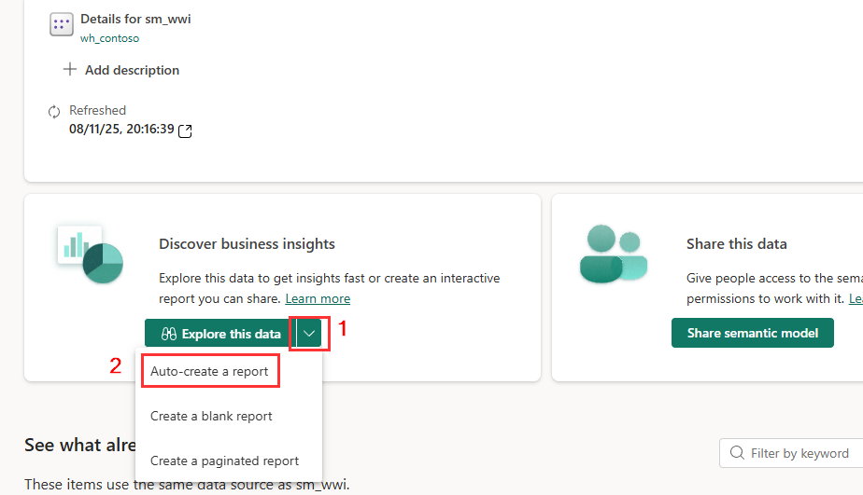

- A report similar to the following image is generated.
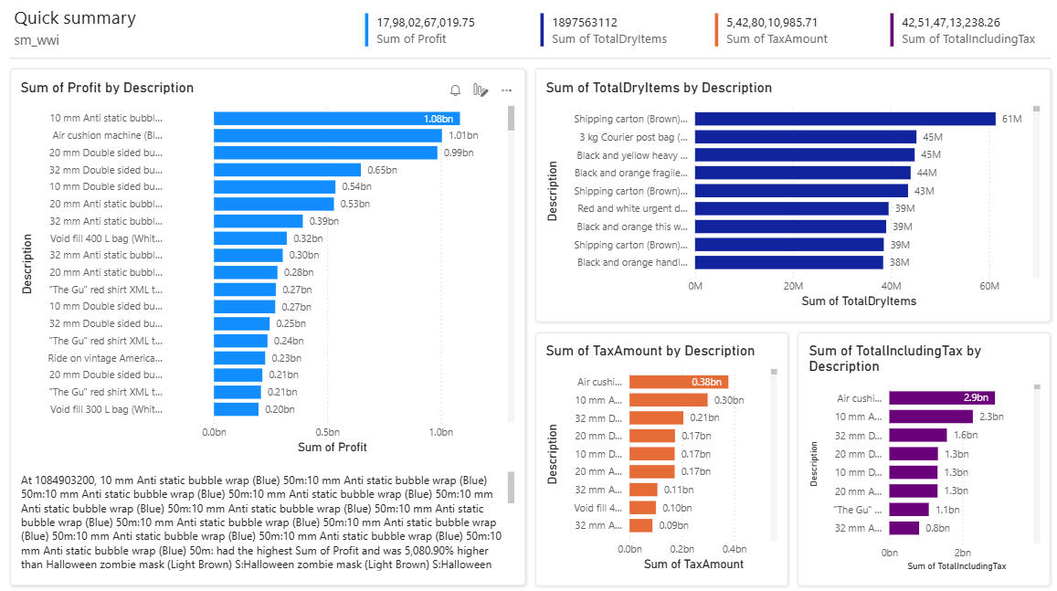
- From the ribbon, select Save.
- In the Save your report dialog box, enter Sales Quick Summary in the name box. In the Save your report dialogue, select Save.
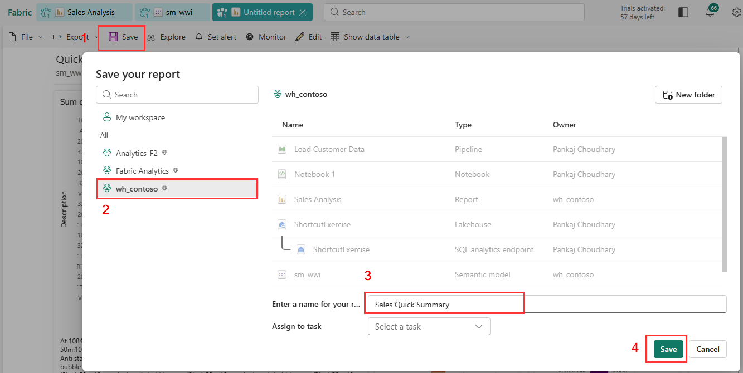
- You will see a notification stating Report saved.

